**Lab 3: Paint Web Application**

**Report**

**Name**: Basel Ahmed Awad **ID**: 19015513

**Name**: Ali Hassan ELSharawy  **ID**: 19016013

**Name**: Louay Magdy Abdel-Halim **ID**: 19016195

**1- The steps required to run application:**

1. We run Spring Boot and Angular
2. We open http://localhost:4200
3. We start using the Paint Application (use the provided user guide if needed)

**2- UML diagram describing your code design:**

Link

<https://drive.google.com/file/d/1qhW8HRSGhf7rX2by5MSEugtZnKXtaNS3/view?usp=sharing>

**3- How you have applied the required design pattern in your code:**

1. Delegation pattern

* Relation between controller and the interface IPaintService
* Relation between controller and the interface Shape
* Relation between controller and Point Class
* Relation between all the shapes classes and Point Class

1. Interface pattern

* Relation between controller and the PaintService
* Relation between controller and shapes classes

1. Prototype pattern

* All shapes classes together with the interface implement *cloneable*  interface to be cloned (in deep copy)

**4- Design decisions:**

Front-End

* We can’t undo or redo options after saving the file.
* We can’t use save options without previously using save as option to create new file.
* We must use Cursor from shape list to be able to use function containing (fill-move-copy-delete-resize) functions.

Back-End

* all shape classes implement an interface so that, any other classes using functionality of such classes be independent from them
* objects are sent between Front-End and Back-End as JSON-objects

**5- snapshots of UI:**

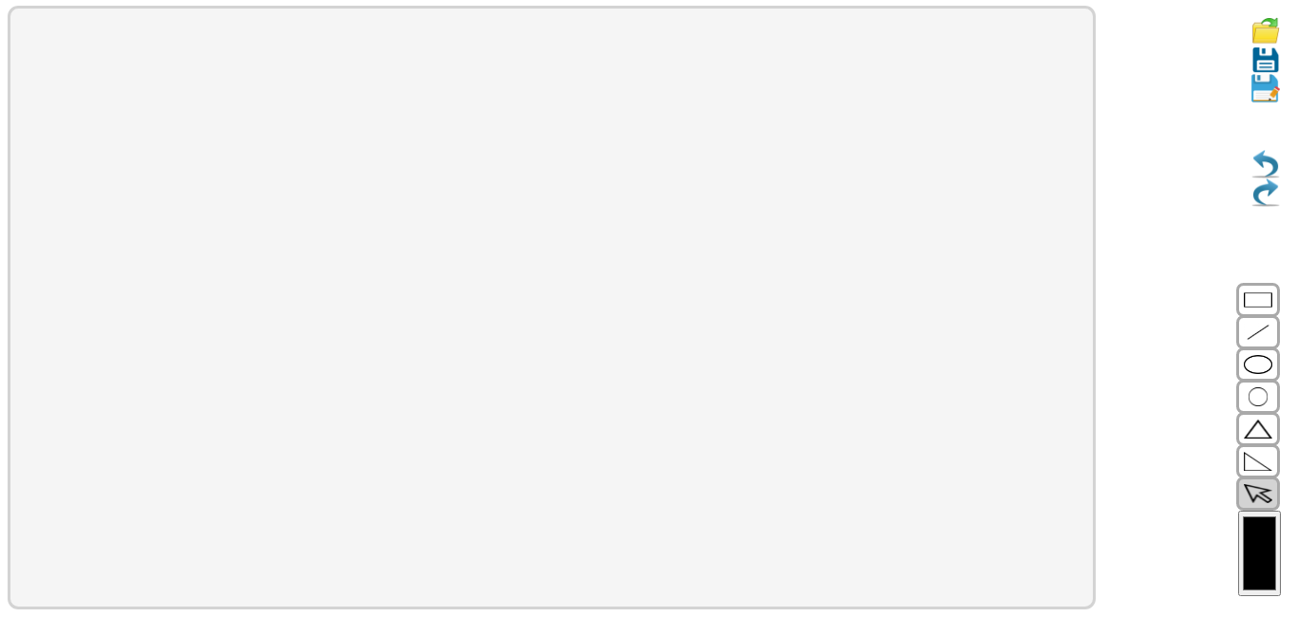

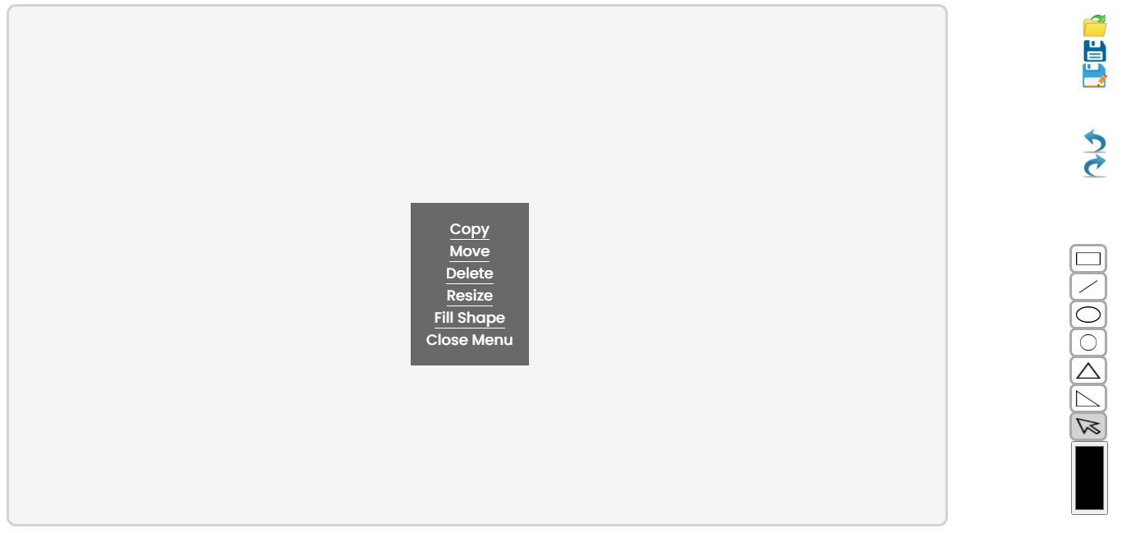**6- User Guide:**

Shapes List (the tool bar at the bottom right side of screen):

contain shapes and colors that can be drawn on Painting area. Just choose a shape and define its border color to draw it

**Cursor:** in shape list

Used to (left)click on a drawn shape to show a menu from which we can (copy - move - delete - resize -fill) the selected shape by the cursor.

Color Button:

we click on it to be able to select border color or background color before drawing or filling the shape.

Menu (the tool bar at the top right side of screen):

We select (undo - redo - save - save as - open) options but there are some assumptions:

* + We can’t save file without previously using save as option to create new file.
  + We can’t undo or redo options after saving the file.
  + In save as option we select the type to save file either json or xml file.

Note that: For all buttons of shape list: The background of color changes when we click on it and select it to be shown that this button is selected